1. 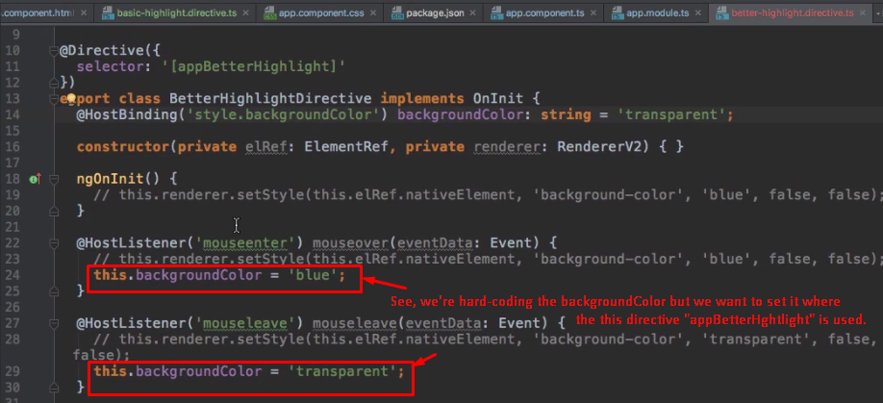
2. **Solution:** Custom property binding. 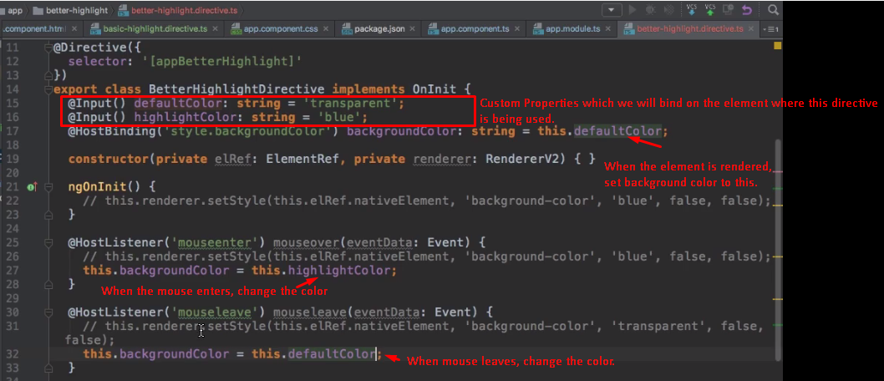
3. 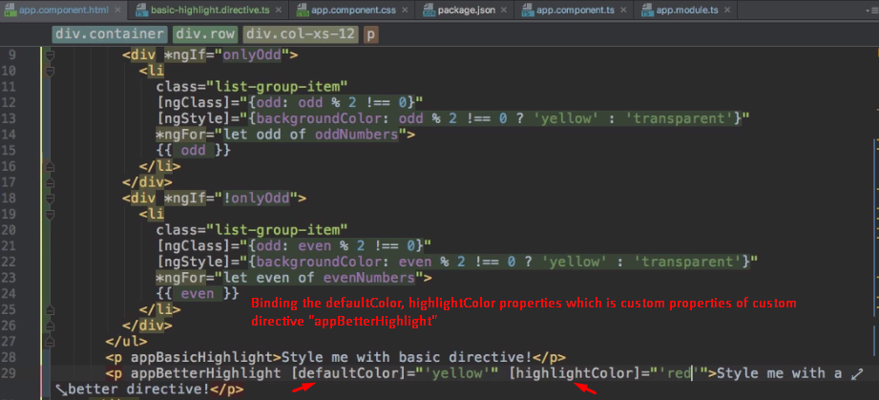
4. 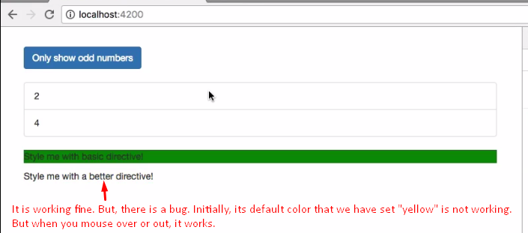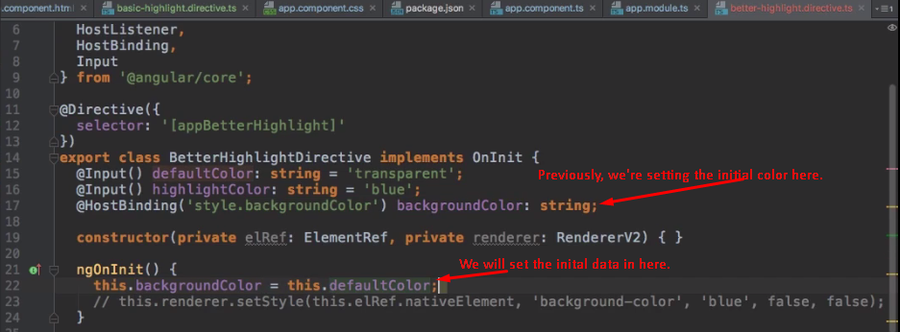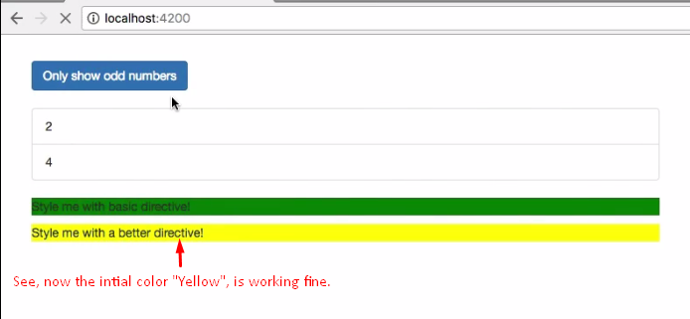
5. **There** are a couple of interesting things we can observe regarding the way we pass down these values. 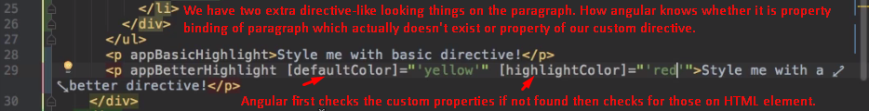
6. 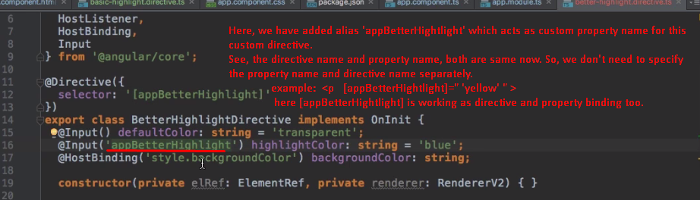
7. 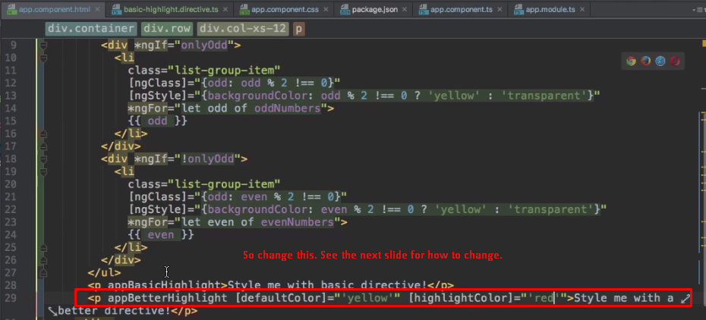
8. 
9. 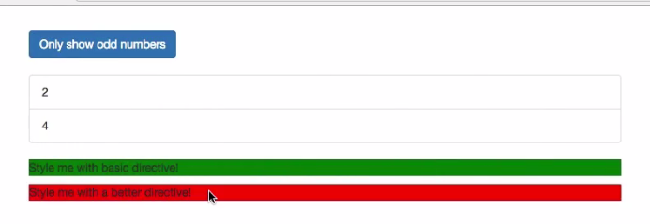
10. 
11. **Jatin: See** we have @Input inside directive which means such directive properties can be bound where directive is used.
    1. Then there is a special case when the property value is string and constant not calculated when setting the property.
    2. In such case, we can concise the property binding.
    3. **1st**: [directiveInputPropertyName]=”’string’”: See when you use [] on the left hand side, the right hand side inside “” is treated as expression.
    4. **2nd:** directiveInputPropertyName=”string”: No need for single quote around string as we didn’t use [] around directiveInputPropertyName.
12. 